Creating a CJA-24 Authorization
STEP 1
On the Home page, in the Appointments’ List section, click the case number link.
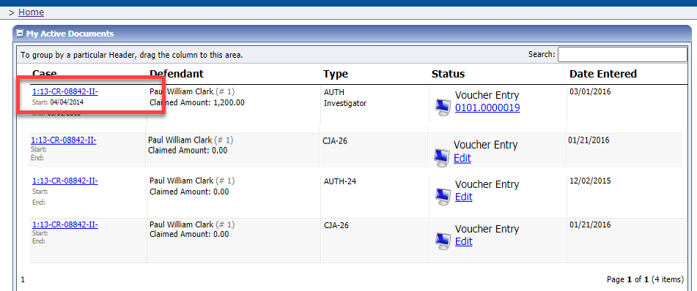

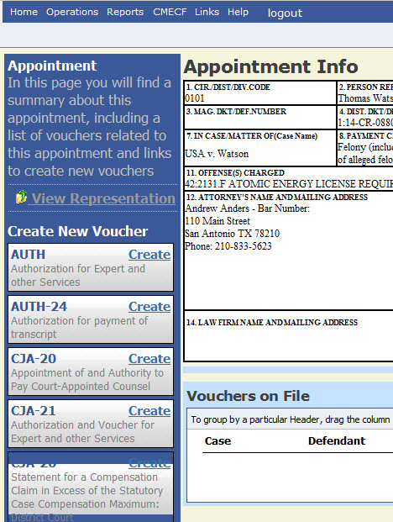
On the left side of the Appointment Info page, in the Create New Voucher section, click the Create link for AUTH-24.
STEP 2

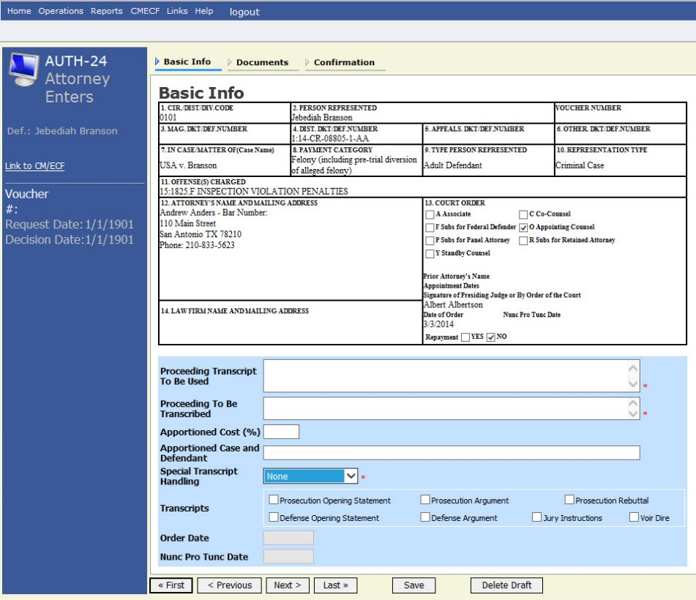
On the Basic Info page, enter the required details of the transcript in the applicable fields.
STEP 3

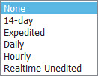
From the Special Transcript Handling drop-down list, select the type of transcript handling. If none of the selections apply, leave the field set to None.

NOTE: Fill in the details for the transcript you are requesting. The required items are marked with a red asterisk. You can attach any relevant documents on the Documents tab.

Confirm and submit the CJA-24 authorization.
STEP 4
Once you select the I swear and affirm the truth or correctness of the above statements check box, the Submit button becomes active. Click Submit.
